Integration Tests for Checkout Controller

# TC01 – Test creditDetailsEntered() method

**Description**: This test evaluates the basic functionality of creditDetailsEntered() method in Checkout controller class. After executing this method, the user can be able to successfully complete the checkout. To execute this method controller class’s run() method should be called.

**Pre-conditions**:

* Room id should be entered.
* Charges should be accepted.
* State should be CREDIT.
* A room should be booked.
* Room should have a booking.

**Post-conditions**:

* User should be checked out successfully.
* Checkout State should be COMPLETED.
* The booking state should be CHECKED_OUT.
* Room state should be READY.

**Data required**:

* Type of the credit card
* Credit card number
* CVV

**Output**:

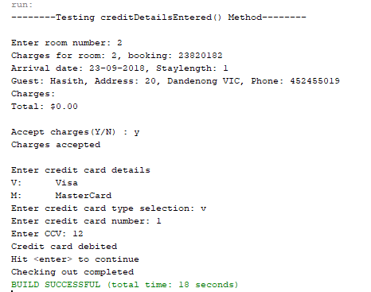

# TC02 – Test creditDetailsEntered() without check in

**Description**: This test evaluates the creditDetailsEntered() method when the room has no active check in.

**Pre-conditions**:

* The room should not have a checked in guest (no active booking).

**Post-conditions**:

* Should display a message saying no active booking found for the room.

**Data required**:

* Type of the credit card
* Credit card number
* CVV

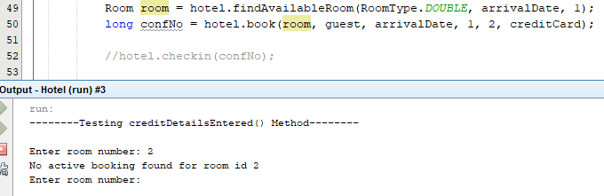**Output**:

# TC03 – Test for Exceptions in creditDetailsEntered() method

**Description**: This test evaluates the creditDetailsEntered() method when the state of the checkout controller is not set. The state is null when the method creditDetailsEntered is called directly.

**Pre-conditions**: state of the CheckoutCTL class should not be CREDIT

**Post-conditions**:

* A runtime exception should be thrown stating “Bad state”.

**Data required**:

* A controller object in which the state is not CREDIT.

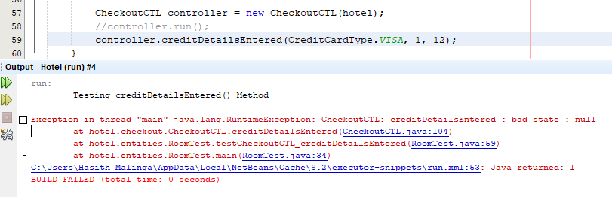**Output**: